- Write a prolog program for forward chaining

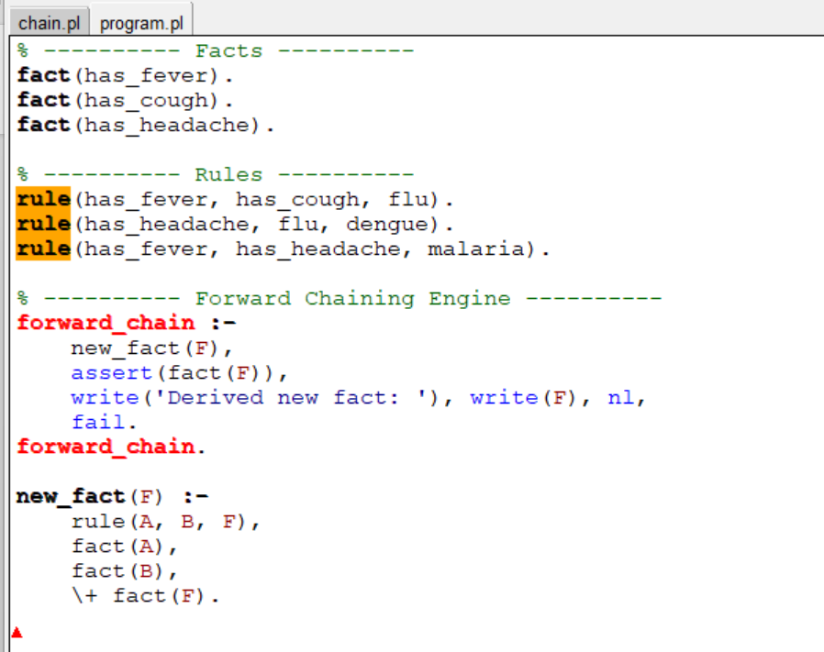

OUTPUT

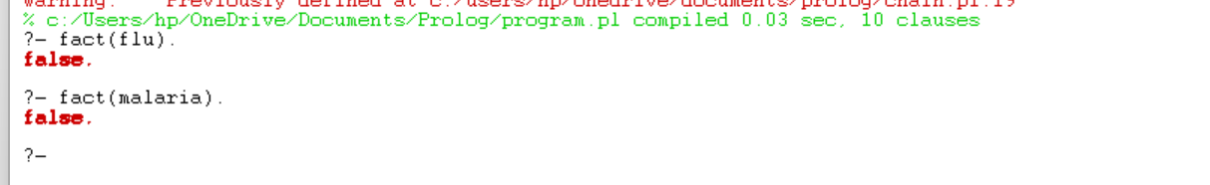

- Prolog program for backward chaining

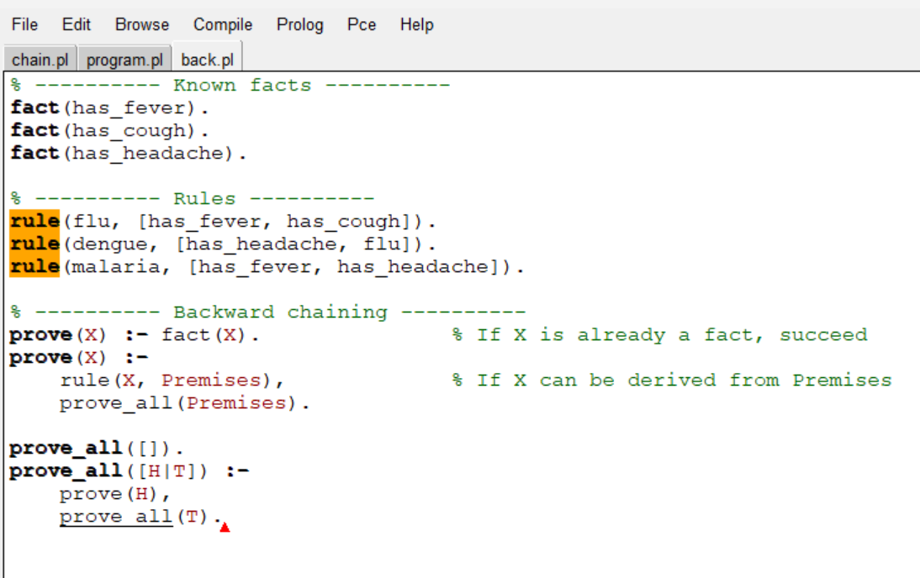

Output:

